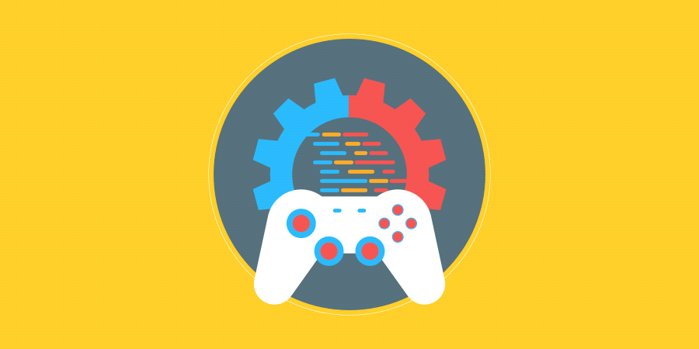

**CyberPunk Platformer**

Sara, Rick, Jules, Luke, Tyreese

**Overview**

Elevator Pitch

The game is similar to Mario but has a different visual design. You’re playing a character who has a chainsaw for an arm in a cyberpunk looking city and you are fighting androids on top of buildings.

Genre/s

* Platformer

Influences

Influence #1

* Mario Bros
* The base mechanics, the playstyle and enemies are very inspired by the platformers in the Mario game series.

Influence #2

* Cyberpunk media
* These inspired the design and setting for the game. It takes place in a futuristic cyberpunk setting.

Influence #3

* Chainsaw Man
* The main character has a chainsaw for an arm

**Story and Gameplay**

Story Synopsis

* You are a young person fighting androids on the rooftops of your city to keep it safe for those who live there.

Main gameplay mechanics (movement, other abilities etc.)

* Shooting, Jumping

Hazards

* Spikes
* Androids